# UML Diagram

# Transaction Diagrams

Not to repeat all the diagrams from the slides, here are some transaction diagrams showing some examples.

Lines with a dash rather than an arrow indicate the returning/termination of the remote function call.

## Read-Only Operation

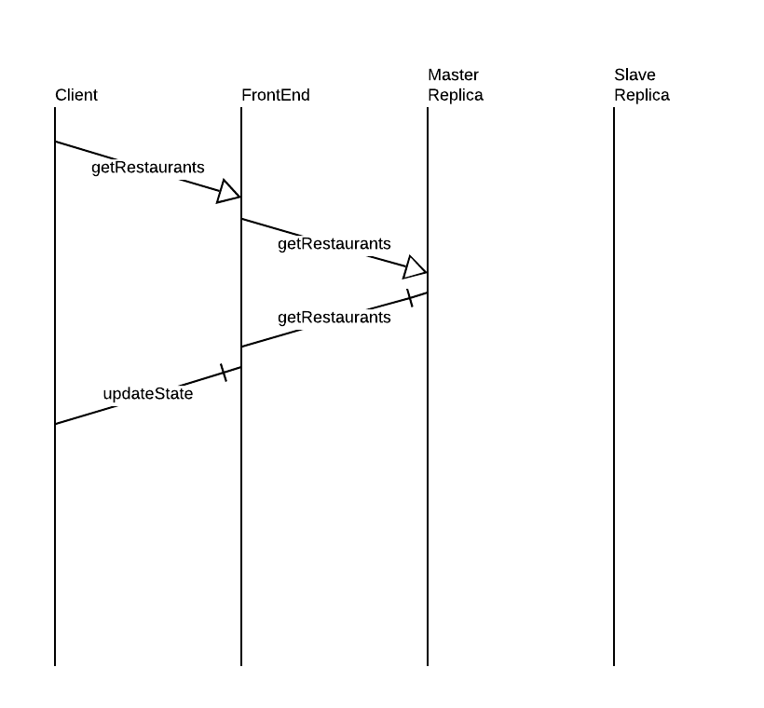

## Writing Operation

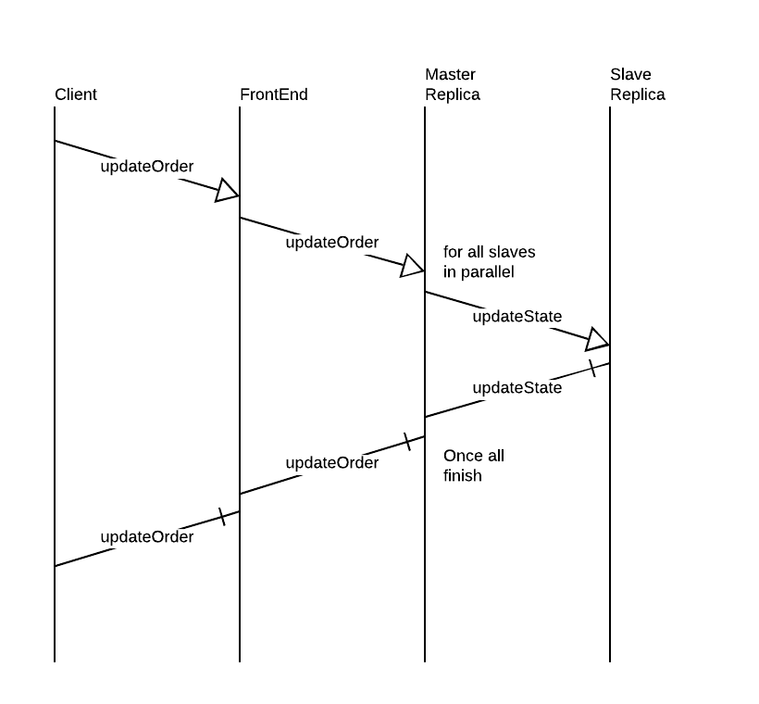

## First Replica Joins

This diagram shows that the source of the initial state for the replicas is the front end

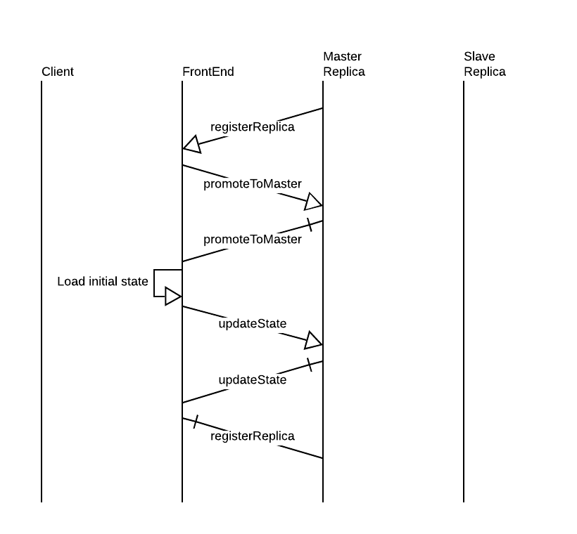

## Non-First Replica Joins

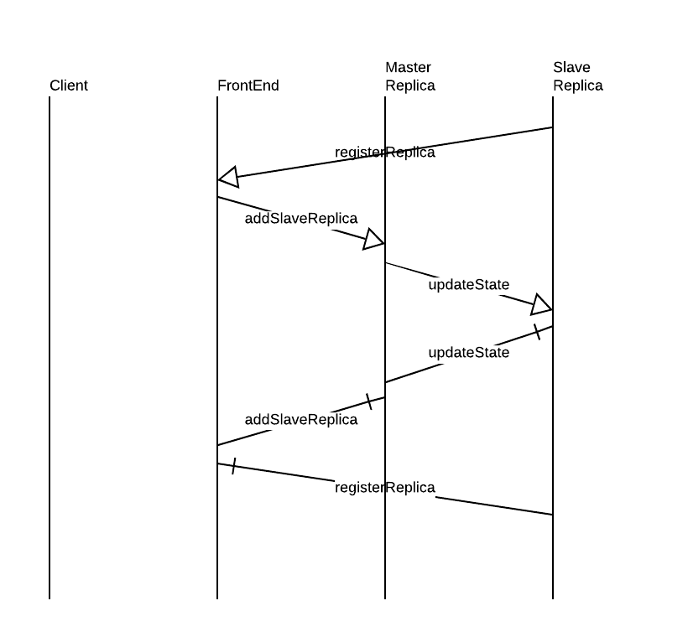

## Master Failure

